Exercise 1
https://github.com/Anthony-Garcia1/my-essay

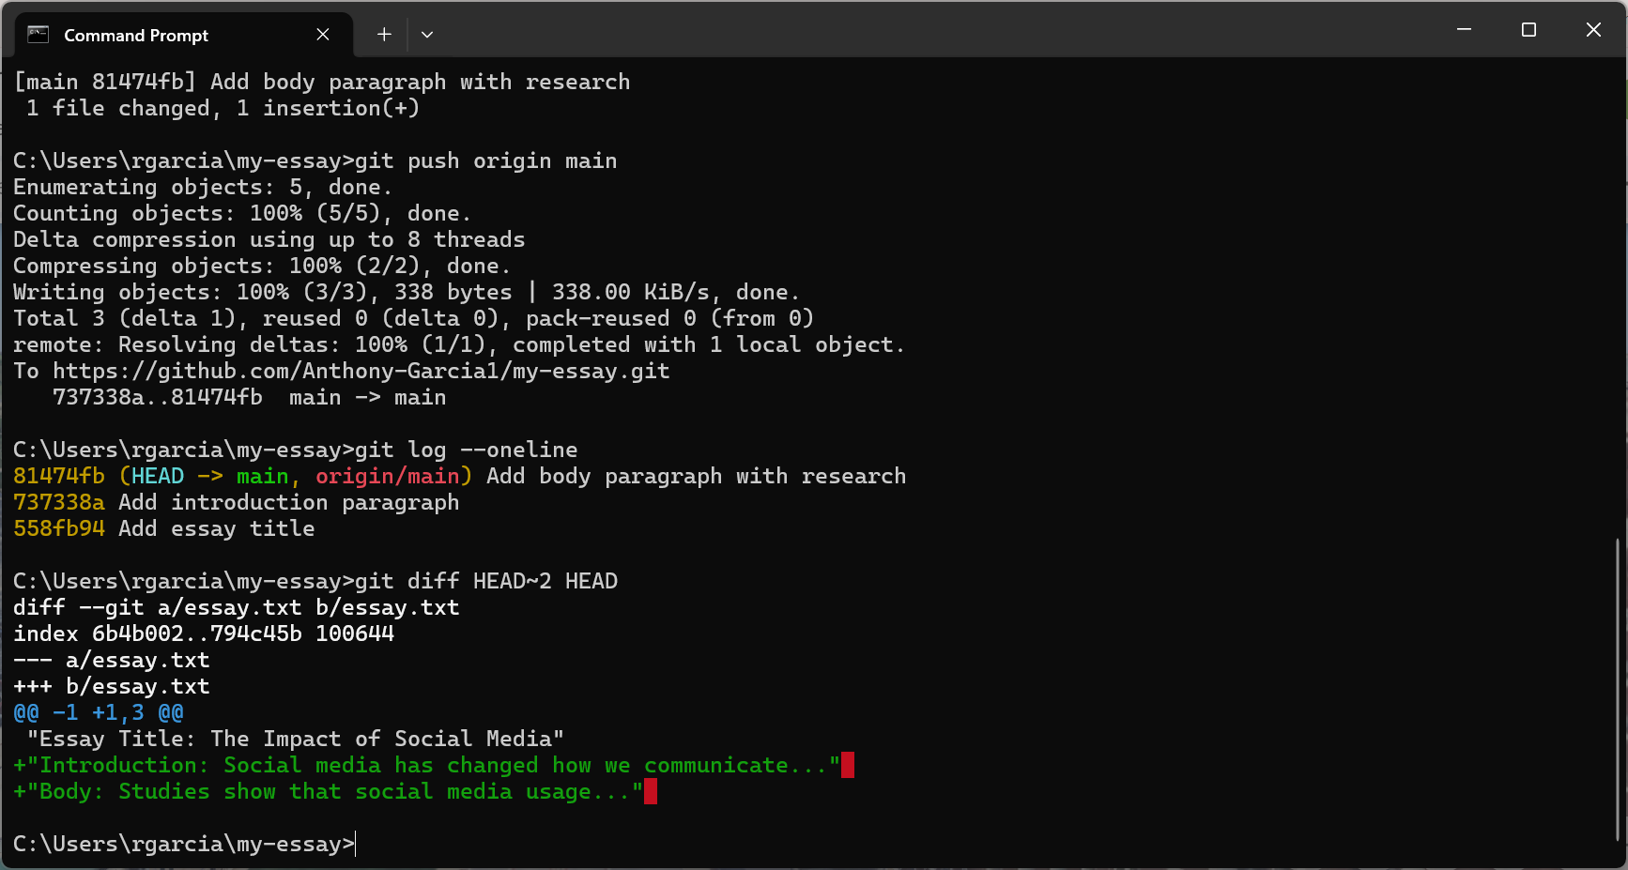
1. Which method helps you understand your changes better? git diff HEAD~2 HEAD helps me understand the changes by showing the differences between two versions of my essay.
git diff HEAD~2 HEAD helped me understand the changes by showing the differences between two versions of my essay.

2. Can you see how your essay developed over time? Yes. Using git log --oneline, I can see the essay's development from the title to the introduction and then the body paragraph. This helps me track the progress of my work over time.
Yes. Using git log --oneline, I can see the essay's development from the title to the introduction and then the body paragraph. This helps me track the progress of my work over time.

Exercise 2
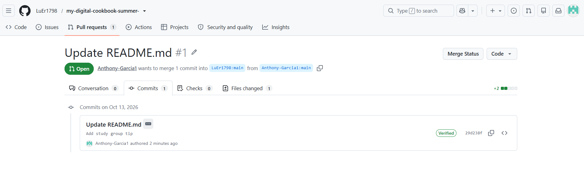

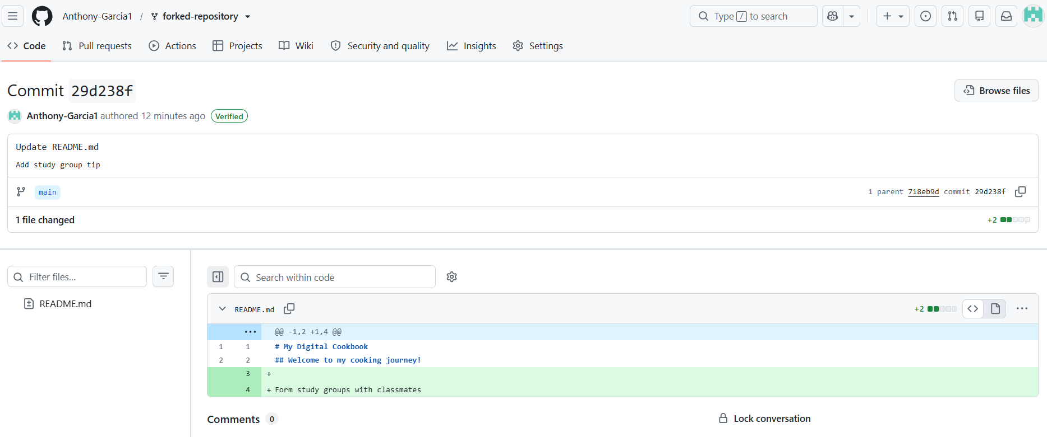

Exercise 3
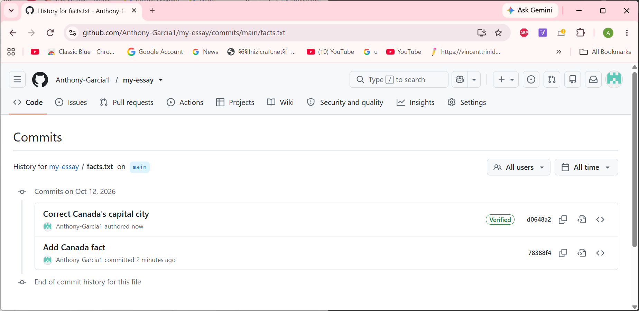
1. Why did the conflict occur?
The conflict occurred because the Skills section was changed differently in the desktop-updates and main branches. Both branches modified the same lines, so Git could not automatically determine which changes to keep.
2. What would have prevented this conflict?
Communicating changes and coordinating work between branches would have helped prevent the conflict. I could also have merged or synchronized changes before editing the same section.
3. In real life, how do you avoid conflicts when working on multiple devices?
Use git pull to get the latest changes before starting work, commit changes regularly, and use git push to upload my work. Using branches and coordinating changes between devices also helps reduce conflicts.
4. What was the most challenging part of resolving the conflict?
Combining the different skills from both branches without losing any information. I had to remove the conflict markers and ensure the final Skills section contained all the intended changes.
5. How did Git help you identify where the conflict was?
Git displayed a conflict message and inserted markers into portfolio.md. The markers identified the changes from each branch.

